**Sri Lanka Institute of Information Technology**

Lab Practical 04

Plan and conduct user research

**User Experience Engineering – IT3050**

B.Sc. (Hons) in Information Technology

|  |  |
| --- | --- |
| **Student ID** | **Student Name** |
| IT19160726 | Nuwantha M. B. |
| IT19152974 | Rathnayaka R.M.M.P. |
| IT19150680 | Fernando B.D.C. |
| IT19038292 | Wickramasinghe A.Y.S.W. |

1. **Introduction**

Cargills online is a mobile application that was developed to provide grocery shopping to consumers through the online platform. This application allows users to order groceries and other household items according to their choice and get them delivered to their doorstep. The user can select the items needed from the wide range of products given. The selected items can be seen in the cart. Payment methods and delivery details are needed to be provided in the checkout process. This application is integrated with payment options such as Visa and MasterCard.

We hope to improve the core functionalities of the application as well as modify all the user interfaces during our execution. We are planning to collect qualitative and quantitative results regarding the existing application by performing user research. We can improve the existing mobile application based on user feedback.

1. **Objectives**

The goals will primarily focus on addressing faults in the present system to improve the user experience of the application redesign.

* To discover the present application's flaws.
* To identify the flaws in the user interfaces.
* To determine which services are unavailable.
* To discover the design's contradiction.
* To determine whether there are any usability difficulties.
* To find the flaws in page navigation.
* How people perceive the application when using its features.
* To watch the users' reactions in real time.

1. **Methodology**

An interview with two users will be conducted as part of the study. We'll assign a few exercises on the mobile app depending on the objectives, and while users are performing them, group members will ask them questions about their experiences with the app. At the conclusion of the interview, the users will be given a questionnaire to provide thorough feedback on their experience.

1. **Interviewing**
   * The interview was conducted with two people who best matched the personas.
   * All four members' functionalities were discussed during the interview.
   * Two members of each team interviewed each of the interviewees.
   * It was much easier to record the interview because it took place over the internet.
   * A script was written to cover all the objectives.
   * The participants were asked open-ended questions.

During the interview, the following questions were asked.

1. Common Questions
   1. Can you tell a few words about yourself?
   2. Have you used Cargill’s mobile app to buy groceries?
   3. Have you used other apps to buy groceries apart from the Cargills app?
2. User Management Function Questions
   1. We will start from the login page, can you tell us about this login page and how the interface looks as a registered user of the app?
   2. Okay now let's move on to the signup page, so what are the opinions about this page when you see the interface and the experience when you first used this page to register?
   3. What do you think about this user profile page? From this page users can edit their entered details as well?
3. Product Management Function Questions
   1. What do you think about this product category page? Does this interface look good, tell us about your opinion?
   2. Okay so what is your opinion about the experience of this product list page? Are you happy about this product list view and filters provided?
   3. After selecting each product from the list, the user should come up here. What is your impression about this view page?
4. Order Management Function Questions
   1. Ok let’s go to home page. What do you think about Cargill’s online home screen? If you satisfy with these features and information
   2. Ok. On this Home page, what are the main features you frequently used?
   3. Ok, then we move to FAQ page, in this page what do you think about this FAQ page? If it helps to clear some doubt about this app.
5. Cart and Checkout Management Function Questions
   1. Let’s start from the review cart screen. Do you think the cart is easily accessible and not confusing at first-time use?
   2. Ok. Can you tell us that is there anything in the review cart screen to be improved? To be clear is it informative enough?
   3. Let’s talk about the checkout process. Do you prefer the current checkout process? If you think of an enhancement in the process you may suggest them as well.
   4. With that being discussed, we want to know your opinion about the choose delivery address screen. Is it easy to use? And what do you think about the interface?
   5. Let’s move to the next screen in the process which is delivery details. This screen is an important screen because this screen lets you confirm the details about the purchase. What is your impression of this screen?
6. **Video recording**

Both the interviews were done inside the framework and with a well-written question script. The interview contains all the members' user interfaces and functionality, as well as user suggestions. As the last round of video recording, both users completed a set of tasks that included the main functions of the system. All failure points/block points were thoroughly documented using these interviews.

Google Drive Link: <https://drive.google.com/drive/folders/1OXwL2QU98RAOoSonz1ZWAR7mWq0i7D1E?usp=sharing>

1. **Questionnaire**

To obtain feedback, a questionnaire was prepared and circulated around a few people.

There are just __ questions in the questionnaire. These questions were created with the intention of achieving the objectives in mentioned above. The questionnaire was designed to cover all each function's functionality and user interfaces. Finally, the information will be gathered in a Google spreadsheet.

Google Form Link: <https://forms.gle/SL6VsrPZNueX1AUK6>

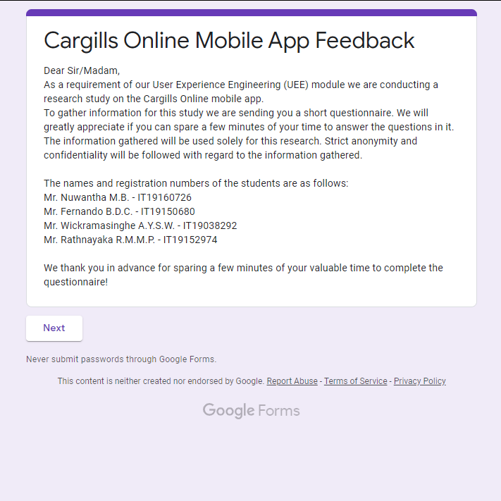

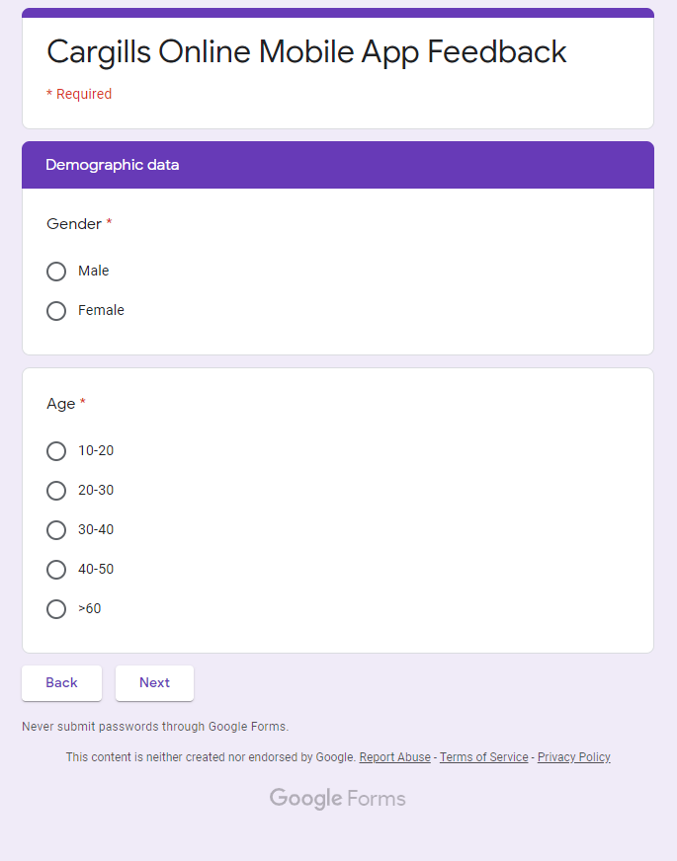

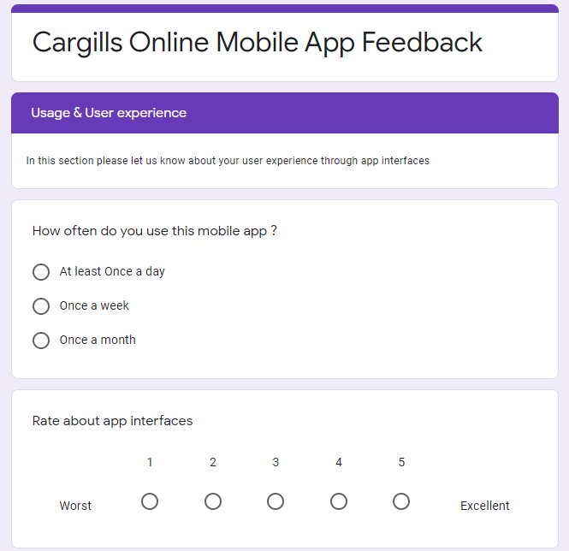

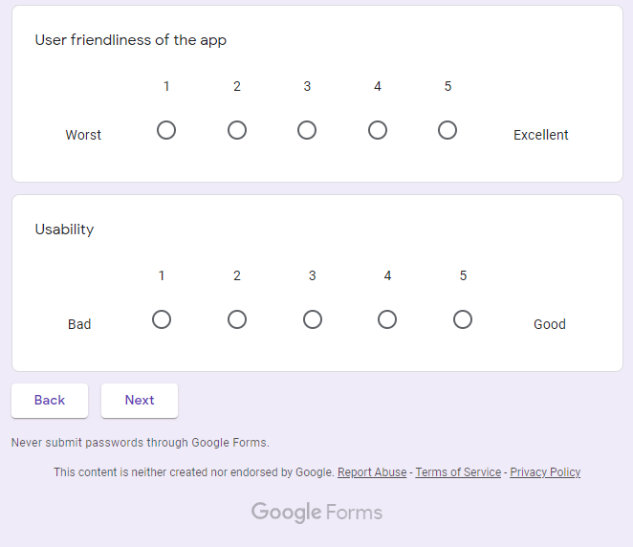

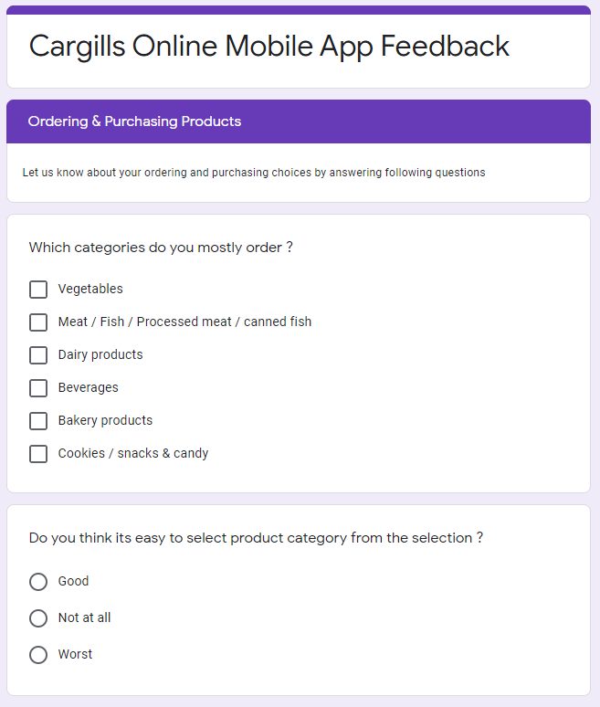

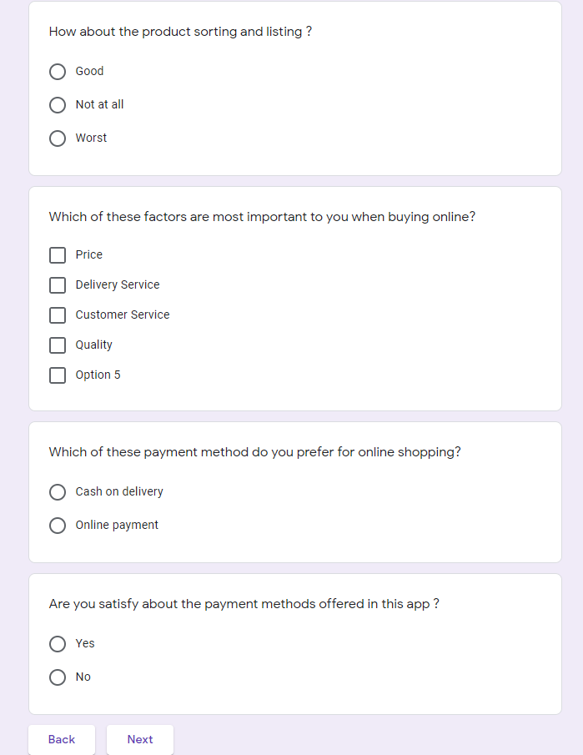

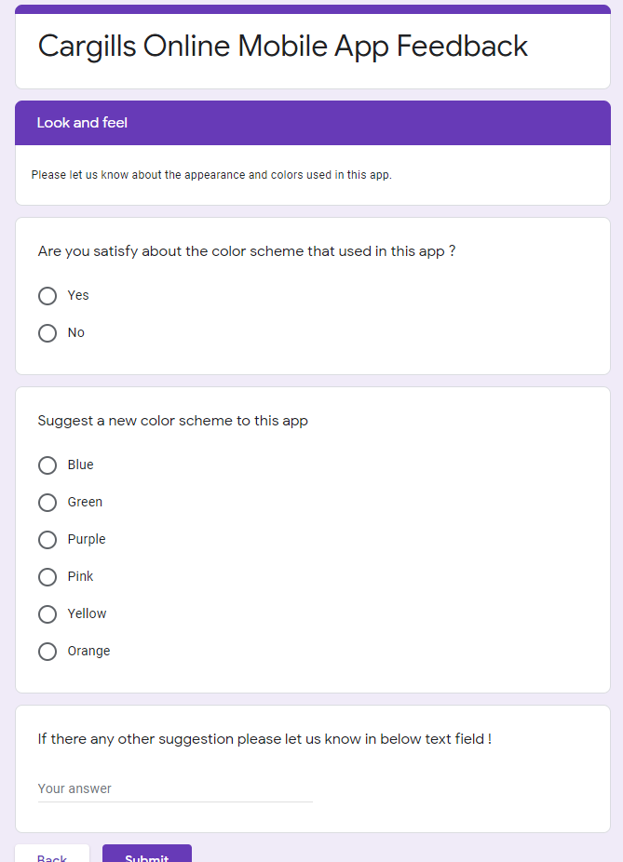

1. **Participant Profiles**

|  |  |  |
| --- | --- | --- |
| **Name** | **Demography** | **Location, Date and Time** |
| Ms. Lakshmi Wasundara | Accountant | Zoom meeting, 29.08.2021 |
| Mr. Nayana Liyanage | Associate Software Engineer | Zoom meeting, 29.08.2021 |

1. **User Research – Tasks/Scenarios**

|  |  |  |  |
| --- | --- | --- | --- |
| **No** | **Task Instruction** | **Target** | **Probes** |
| 01 | Sign In |  |  |
| 02 | Sign Up |  |  |
| 03 | Edit user data |  |  |
| 04 | Select a category |  |  |
| 05 | Find a specific product |  |  |
| 06 | Add a product to the cart |  |  |
| 07 | Add an Item to the cart and access the cart |  |  |
| 08 | Add a new address |  |  |
| 09 | Proceed to checkout |  |  |
| 10 | Click the top image and navigate to those products |  |  |
| 11 | Navigate to FAQ page |  |  |